Certificate printing user guide

To use this functionality on eDofE, you’ll need to print on our new-style certificates. But before you order any blank copies from ASL, don’t forget to do a test run on a plain piece of A4. This will ensure you know how to use the new functionality and have no problems with double-sided printing.

Who can print certificates?

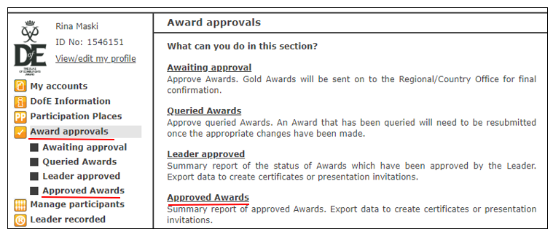
DofE Leaders, Administrator, Managers and Head office staff can print Bronze and Silver Award certificates via eDofE. Helper and ASL account holders don't have access to the functionality to print these certificates.

Where can I print certificates?

You can print certificates via ‘Award approvals’ from the left-hand menu and under ‘Approved Awards’.

You can filter the participants by using the ‘Location’, ‘Levels’ and ‘Period’ filters.
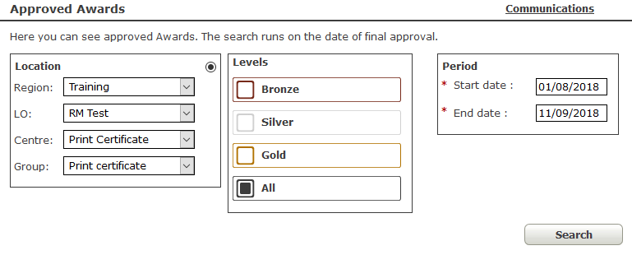
How do I print certificates?
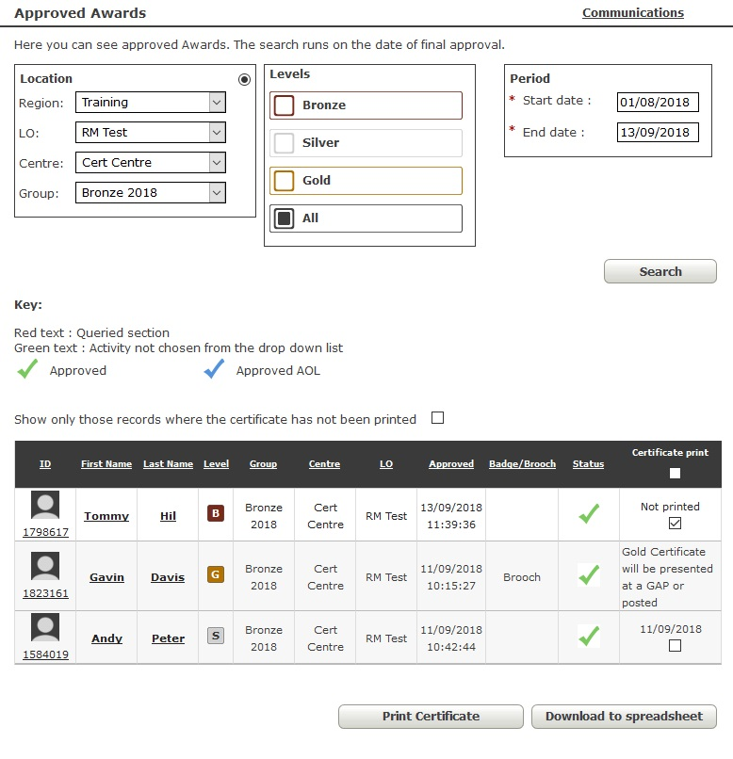
- Choose the certificate(s) you want to print.
- You can select the tick boxes individually, select more than one tick box to print multiple certificates or select the tick box at the top of the column to select all the certificates available to print.
- By default, all records which match your search criteria are shown on screen. If you want to see only those Awards for which a certificate hasn’t yet been printed, you can do this by ticking the ‘Show only those records where the certificate has not been printed’ box.
- Click the ‘Print Certificate’ button at the bottom of the page.
- A PDF of your chosen certificate(s) will be downloaded on your computer. Please note: the downloaded document depends on the format you've chosen to use on your computer. It would be best to use a PDF format.
- Print your certificates onto the certificate templates (these can be ordered through ‘Essentials’ on eDofE by DofE Managers and Administrators who have the permission to purchase restricted products).

Additional notes:

- Not printed (in the certificate print column): their certificate hasn't been printed.
- Date, i.e. 11/09/2018: if a certificate has been printed more than once, this will show the most recent print date.
- Gold certificates cannot be printed through eDofE. These will be presented to the young person at a national Gold Award Presentation or posted to their home address.

Printing tips

- Make sure that your printer is set to ‘Actual size’, not ‘Fit to page’ or any other sizing option.
- Depending on the type of printer you have, if you see any tabs that say you can print on both sides of the paper, please select this option. This will ensure that the young person's information prints on both sides of the certificate.
- If you don't have the option to select ‘two-sided printing’, you will have to manually turn the certificates to print on both sides:

Step 1 – Please insert the certificate facing downwards. This will print the name, eDofE ID number and the date on the front side of the certificate.
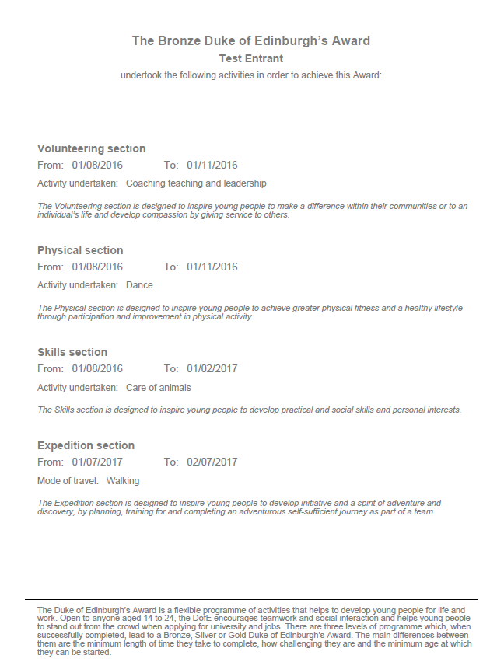
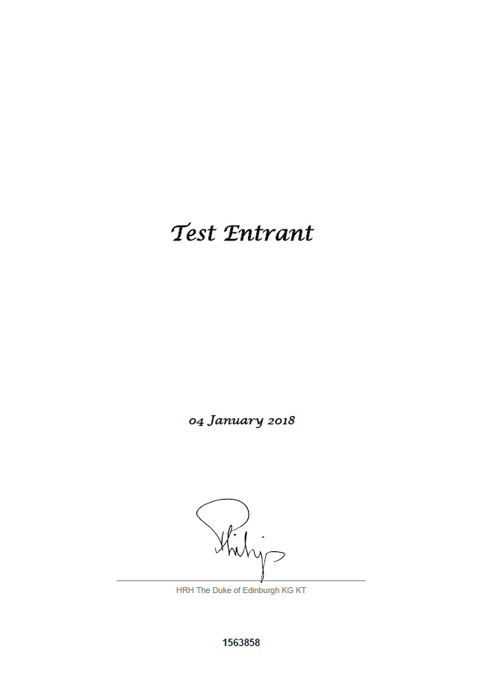
Step 2 – Insert the back side of the certificate facing downwards. This will print the participant's activity information.

Have a technical issue?

If you experience any technical problems using the new printing functionality on eDofE, please contact our Technical Support team at eDofE@DofE.org.

