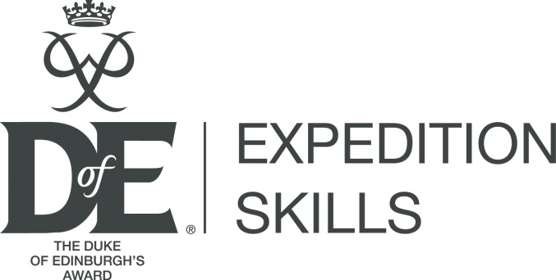
September 2017

DofE Expedition Skills: Course overview

The DofE Expedition Skills (DES) course was added to the DofE’s Modular Training Framework (MTF) in 2016. The MTF is a collection of training courses and e-learning modules available to support adults in DofE delivery roles. The DES is a basic expedition skills course, intended to give expedition support staff the theoretical and practical skills needed to support DofE expedition delivery and training.

For full information, see the course webpage and flyer at: www.DofE.org/des

Frequently asked questions:

What is the DES course?
The DofE Expedition Skills course is an ‘entry level’ expedition skills training programme, which does not require any previous experience to attend. It teaches the basic skills needed to support expeditions on foot in normal, rural and open countryside (for example, normal Bronze expedition terrain). The course consists of approximately 30 hours of practical and theory learning.

Why was the DES course created?
The DofE identified that many members of the DofE network were looking to increase their expedition skills experience. The ability for Licensed Organisations (LOs) to support expedition training and delivery has been reduced, by the move away from our traditional delivery structure and with the increase in the number of schools being directly licensed.

By offering a course that delivers the specific skills needed to deliver expeditions, the DofE hopes to build capacity across our network and ensure more DofE expeditions are run successfully.

Who should attend the course?

This course is suitable for adults who wish to gain practical experience in the expedition skills needed to deliver expeditions on foot in normal, rural and open countryside (for example, normal Bronze expedition terrain).

Are there any entry requirements?
No, it is a basic course, intended for beginners. The course does require a certain level of mobility and physical fitness, which will be outlined in the joining instructions.

Is the DofE approving Leaders and expedition support staff now?
No. LOs continue to have full responsibility for the leaders and expedition support staff they use.

Does completing the DofE Expedition Skills course qualify you to lead, supervise or support expeditions?
That is entirely a decision for a Licensed Organisation. Completing the DES will give learners a thorough grounding in the skills needed to support Bronze expeditions. However, LOs will always need to make the decision and are likely to have other requirements (e.g. first aid, which is not covered in the DES).

What does mean for the other DofE training modules?
This is a new DofE training course and has a new e-learning module, the Introduction to the Expedition section. The other MTF modules remain available. The Expedition Supervisor Training Course (ESTC) is being updated to coincide with the release of the DES.

Does this replace the ESTC?
No. The DES is not specifically aimed at any role, it is intended to help develop the expedition skills needed to support expeditions. It is an addition to the DofE’s training scheme and complements the ESTC.

The ESTC is the training course for Expedition Supervisors and has just been updated. Expedition Supervisors are responsible for the health and safety of an expedition team.

Expedition Supervisors are expected to have expedition skills and experience before they attend the ESTC.

Will I have to do a test or assessment?
The Course Director and Tutors will check throughout the course to see that you have understood the course and the individual elements they have explained. There is no formal test, but the trainers may ask individuals to demonstrate that they have understood the learning. Learners may be deferred if they have learning outcomes that aren’t met throughout the course.

What qualification will it give me?
The DES is a DofE course and part of our Modular Training Framework. You will receive a DofE certificate that outlines the learning areas you have covered. This course is not accredited by any external bodies.

Is the course compulsory?
This is not a compulsory DofE course. LOs may choose to send delegates (and insist that they attend) and that is entirely a decision for them. The DES is not compulsory for any particular DofE role.

I have lots of experience – can it count towards the course, meaning I don’t have to go?
There is no prior learning for this course. However, the course must be attended in full (and the learning outcomes demonstrated) in order for a delegate to receive the course certificate.

Can LOs/AAPs run the course?
No – at present, the DofE Expedition Skills course can only be run by DofE Region/Country Offices and by DofE staff or volunteers.

Where do I go to find out more – or to book onto a course?
Visit the DES webpage: www.DofE.org/des. Further information is available and the ‘Opportunities Finder’ can be used to find a course to book onto.

