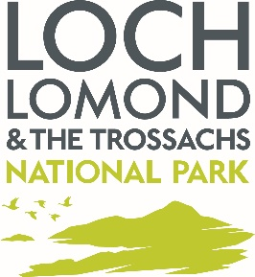
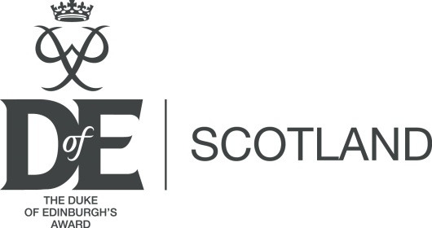

Duke of Edinburgh’s Award group camping permit application form

- This form is for DofE groups who want to camp within the area of the Loch Lomond & The Trossachs National Park covered by the Loch Lomond & The Trossachs Camping Management Byelaws 2017, as part of a DofE expedition.
- The contact details provided for the person submitting the green form(s) will be used by Loch Lomond & The Trossachs National Park Authority (“the Park Authority”) to contact you and notify you of decisions regarding the application.
- Only one permit application form should be submitted where multiple teams are planning to camp at the same location. Green forms and route maps for all teams intending to use the location on the same date should be included alongside this form.
- The green form(s) and route maps accompanying this form provide details about the number of young people, contact details for a leader, and context of how the proposed campsite fits into the expedition.
- This application is for one location and date; further applications should be submitted for other dates or locations.

DofE Centre name | Click here to enter text.
Number of teams planning to camp together (which will be the number of green forms accompanying the form) | Click here to enter text.
Camp location where the exemption is being applied for (Grid reference and description) | Click here to enter text.
Date of arrival at location | Click here to enter text.
Date of departure from location | Click here to enter text.
Number of leaders camping in addition to young people listed on the green forms and location details if different to camp location above | Click here to enter text.
Total number of tents at location | Click here to enter text.
What arrangements are being made for toileting? | Click here to enter text.
Do you intend to have any fires or BBQs? | Choose an item.
If yes to the question above, please provide details of how many and what size and how you will be complying with Byelaw 8. | Click here to enter text.
Has the landowner been notified or asked for permission to camp? | Choose an item.
Please provide details of the landowner | Click here to enter text.
Signature of applicant
Date of application

Please send this form, along with the relevant green forms and maps to:

Camping Byelaws
Loch Lomond & The Trossachs National Park Authority
Carrochan
Carrochan Rd
Balloch
G83 8EG

campingbyelaws@lochlomond-trossachs.org

01389 722001

For an application to be considered valid you must;
- Complete all relevant sections of this form
- Have the form signed by a person over 18 years of age
- Provide a minimum of 4 weeks’ notice.
- Provided accompanying green forms and maps for the teams concerned.

Applications will be acknowledged by the Park Authority and considered within 15 working days of receipt and decisions will be communicated to applicants in writing (email and/ or hard copy).

The Park Authority may choose to assign certain conditions to the approval of an application over and above the usual camping permit terms and conditions. In order to assess your application for exemption from the Byelaws, we are requesting some personal information from you, in this form and accompanying green form(s). The personal information you provide will only be used for this purpose. Your information will be processed by the Loch Lomond & The Trossachs National Park Authority securely and in accordance with Data Protection legislation.

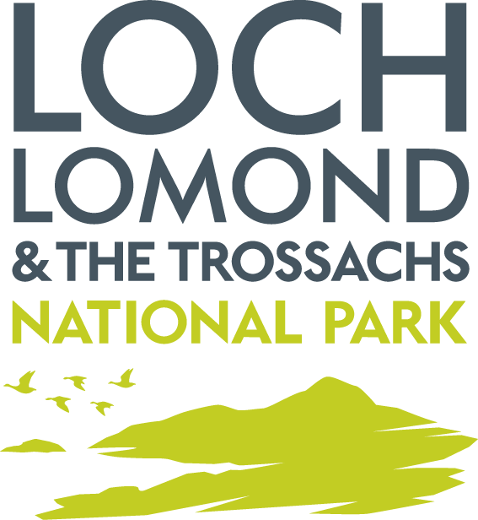
Loch Lomond and the Trossachs National Park Authority
PRIVACY NOTICE

The information you have provided (“Your Information”) will be processed by Loch Lomond & The Trossachs National Park Authority,Carrochan,Carrochan Road,Balloch,G83 8EG, for group bookings accepted for organised groups that have been authorised to camp in a camping management zone.
You can contact the Park Authority on 01389 722600 or info@lochlomond-trossachs.org
The Park Authority’s Data Protection Officer is our Governance Manager who can be contacted on the below noted details:
Carrochan Road,Balloch,G83 8EG
Email: info@lochlomond-trossachs.org
Tel: 01389 722600

How will your information be used?
Your Information will be used to:
- We will use your email address to email you your booking confirmation and other related information regarding your booking.
- We may use your telephone number, mobile phone number or email address to contact you regarding your booking.
- Our Ranger Service may use the personal data you submit during the booking process to identify you when patrolling in Loch Lomond & The Trossachs National Park.
- We may use your personal data to contact you in the event of a suspected breach of the Loch Lomond & The Trossachs National Park Camping Management Byelaws 2017. Terms and Conditions apply to all bookings made with Loch Lomond & The Trossachs National Park Authority. By making a booking you agree that you have read and agree to these Terms and Conditions.
- We may use your personal data to inform evaluation reports of the Camping Management Byelaws.

What is the legal basis for us to process your data?
The legal basis for processing Your Information is:
Compliance with the Loch Lomond & The Trossachs National Park Camping Management Byelaws 2017.
Do I have to provide my information?
You do not have to provide your information to the National Park Authority
Without the correct information however we may not be able to successfully complete an online booking.
How long will you keep my Information?
We will hold your information from the end of the year it was provided for a period of 3 years. Your information will be retained for the minimum period necessary. Your information will be destroyed under confidential conditions after this period.

Who will you share my information with?

Your information will be accessed by Park Authority staff for the purpose of enforcement of the Loch Lomond & The Trossachs National Park Camping Management Byelaws 2017.

The Park Authority will generally comply with requests for specific information from other regulatory and law enforcement bodies where this is necessary and appropriate.

Will you transfer my data outside the UK?

In general the Park Authority does not transfer personal data outside the UK and on the rare occasions when it does so the Park Authority will inform you.

The Park Authority will only transfer data outside the UK when it is satisfied that the party which will handle the data and the country it is being processed in will provide adequate safeguards for personal privacy.

Your Rights

You have the right to:

- Access Personal data held about you

You have the right to access the personal data the Park Authority holds about you. This right is called a Subject Access Request, often referred to as a SAR.

You can receive a copy of your personal data held by the Park Authority, details on why it is being used, who it has been/will be shared with, how long it will be held for, the source of the information and if the Park Authority uses computer systems profiling to take decisions about you. Details on how to submit a Subject Access Request can be found on our website at:

http://www.lochlomond-trossachs.org/park-authority/freedom-of-information/accessing-personal-information/

- Rectification of Personal Data

You have the right to request that the Park Authority corrects any personal data held about you that is inaccurate.

- Erasure of Personal Data

You have the right to request that the Park Authority deletes personal data about you. This is known as “the right to be forgotten”.

You can request erasure of personal data in certain circumstances , for example:
- The personal data is no longer necessary for the purpose it was collected
- It is being processed unlawfully
- The personal data has to be erased due to a legal obligation the Park Authority is subject to

- Restrict Processing

You have the right to request that the Park Authority restrict processing your personal data if
- You think the personal data is inaccurate
- The processing is unlawful
- The Park Authority no longer needs the personal data but you may need it for legal purposes
- You object to the Park Authority processing for the performance of a public interest task or any official authority vested in the Park Authority.

- To Object

You have the right to object to the Park Authority’s use of your personal data. The Park Authority will have to demonstrate why it is appropriate to continue to use your personal data.

Complaints

If you are unhappy with the way the Park Authority has processed your information you have the right to complain to the Information Commissioner’s Office:

The Information Commissioner's Office - Scotland
45 Melville Street
Edinburgh
EH3 7HL

Telephone: 0303 123 1115
Email: Scotland@ico.org.uk
You should however raise any concerns regarding our handling of your information with the Park Authority in the first instance. Details of our complaints process can be found at:
http://www.lochlomond-trossachs.org/park-authority/how-to-make-a-complaint/
The Park Authority does not use profiling or automated decision making processes.

