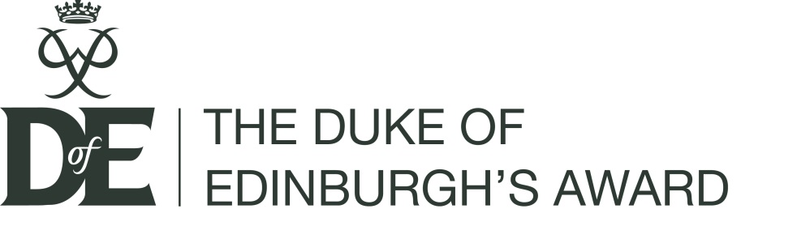

DofE Difference – template email copy

Hi XXX,

As you might already know, I run The Duke of Edinburgh’s Award (DofE) at our school.

It’s an amazing complement to academic life, helping our students stretch their comfort zones, build the confidence they need to get ahead and gain the skills that employers want in the workplace.

I’ve also got a lot out of volunteering for DofE as it’s helped me develop great working relationships with students that benefit classroom dynamics and given me leadership skills.

Volunteering for DofE doesn’t have to involve outdoor hikes (although the expedition is fun!). There are lots of different volunteer roles with varying time commitments. Our students engage in active citizenship, giving back to our community, improve their fitness and learn a skill – all activities that need support.

So, why not join me and volunteer for DofE? More volunteers mean we can enable more of our students to take part in DofE and develop the skills they need to succeed in life and work. Together we can make a real and lasting difference.

With thanks,

[insert name]
[insert email address and phone number]

