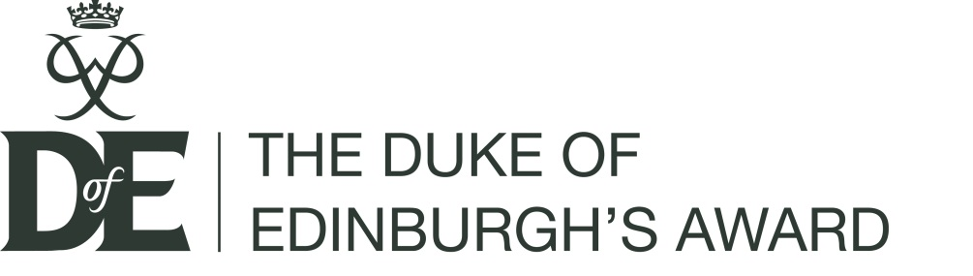

Role description: Dof E Manager (within DLCs)

Hours: Variable (dependent on scale of Licensed Organisation)
Reports to: DofE Licence holder
Appointed by: DofE Licence holder (in consultation with DofE Regional/Country Office)
Key contacts: DofE Licence holder, DofE Award Verifier, DofE Coordinators, DofE Administrator,
DofE Leaders, DofE Regional/Country Office

Summary and main purpose
The Duke of Edinburgh’s Award (DofE) is a UK charity that makes a difference to young people’s lives and prepares them for life and work. Over 275,000 young people per year from every possible background take part in the DofE programme to broaden their horizons, develop their leadership skills, learn to work with others, volunteer in their local communities, increase their employability, and prove to themselves they can succeed at a serious challenge.

DofE Managers perform a vital role on behalf of the Charity. They ensure that The Duke of Edinburgh’s Award is operated in accordance with the terms of the Licence agreement and support the DofE’s mission. They develop, support and promote the delivery of the DofE within the remit of their Licensed Organisation.

The key tasks of the role are to:

Young people
KT1. Ensure the delivery of high quality programmes and identify opportunities for increased participation.
KT2. Manage the provision of a safe and enjoyable DofE programme for participants from the Licensed Organisation.
KT3. Issue badges and certificates on completion of Awards.
KT4. Arrange suitable opportunities to celebrate young people’s DofE achievements.
KT5. Purchase and assign Participation Places.
KT6. Deal with complaints and queries in an efficient manner.

DofE groups
KT7. Authorise, manage and set up sufficient DofE groups to ensure access to a DofE programme for all participants who wish to take part.
KT8. Approve the appointment of Leaders, Instructors, Supervisors and Assessors and ensure they have access to appropriate training/qualifications for their role.
KT9. Manage and support Leaders – support them in their role, ensure they have undergone appropriate training and actively manage the recruitment of new Leaders when necessary.
KT10. Use eDofE to actively manage DofE groups.
KT11. Ensure that all DofE groups are adhering to the correct policies and procedures.
KT12. Run an active volunteer recruitment programme.

General
KT13. In conjunction with the relevant DofE Regional/Country Office develop, implement and review a DofE development plan, which includes supporting the DofE to meet its strategic aims.
KT14. Use eDofE to support the delivery and management of DofE within the Licensed Organisation.
KT15. Use the eDofE reporting functions to measure performance and set development targets.
KT16. Attend at least one meeting/event organised by your DofE Regional/Country Office per year to keep up to date with DofE developments.
KT17. Ensure compliance with all aspects of the DofE Licence.
KT18. Be a champion for the DofE within the Licensed Organisation and actively promote the DofE within the local community.

Other considerations
DofE Managers must undertake the e-induction and Introduction to the DofE courses.

DofE Manager: Skills and knowledge

Essential:  - An ability to communicate with adults and young people, both verbally and in writing.  - An ability to organise and plan effectively.  - IT literate.  - Ability to manage staff effectively.  - Able to provide inspirational leadership and motivate adults.  - Build, maintain and facilitate effective working relationships with a wide range of people.  - Plan, manage and monitor own tasks and time.  - Construct and implement long-term plans that improve and expand the DofE programme offered to young people and identify any training, resources and other needs required to undertake this work. | Desirable:  - Experience of running DofE programmes.  - Staff or volunteer management.  - Experience of working with young people.  - Knowledge of current issues affecting young people.
Qualities:
• Integrity.
• Respected decision maker.
• Committed to ensuring high standards.
• Commitment to DofE’s guiding principles.
• Flexible approach.
• Self-motivated.

