Stay safe - Please follow footpaths where possible.
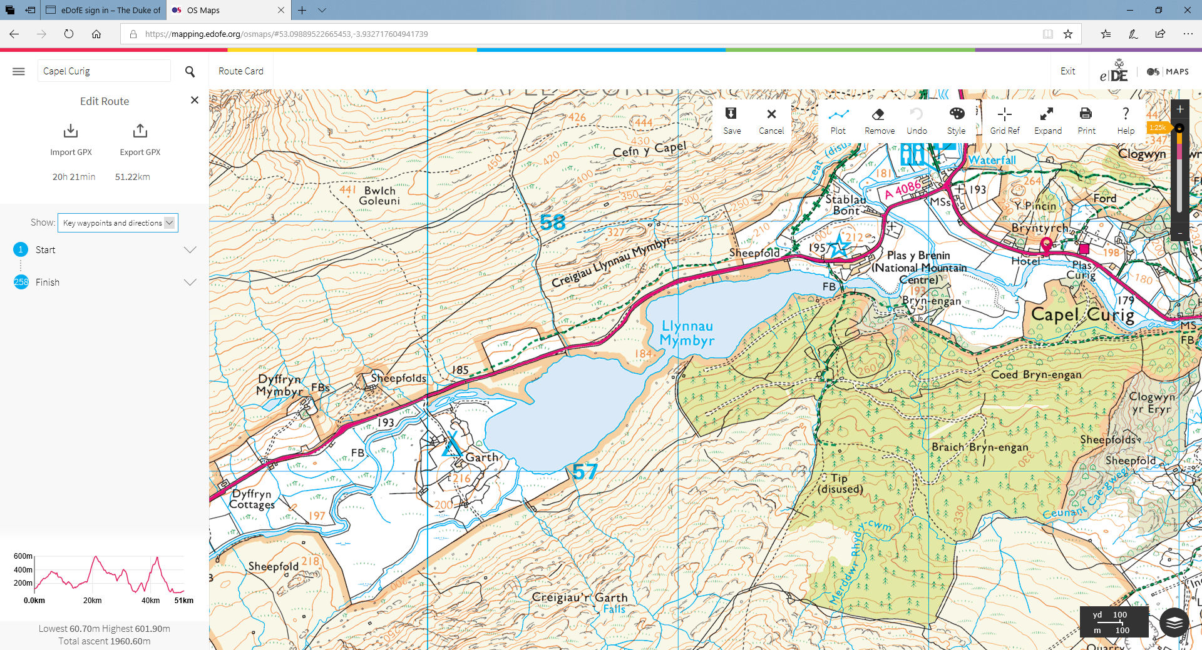

Groups visiting the Snowdonia area and following the footpath south from the Sheepfold (Plas Y Brenin) should remain on the footpath running adjacent to the A4086 road rather than walking on the main road.

