IMPORTANT INFORMATION FOR GROUPS VISITING THE BRECON BEACONS

Dan y Mynydd, Tregoyd, Brecon, Powys, LD3 0SS

Please note that the small holding has 3 rights of way across the land highlighted in orange below. Please respect the animals and landowners, follow the rights of way and leave no trace.

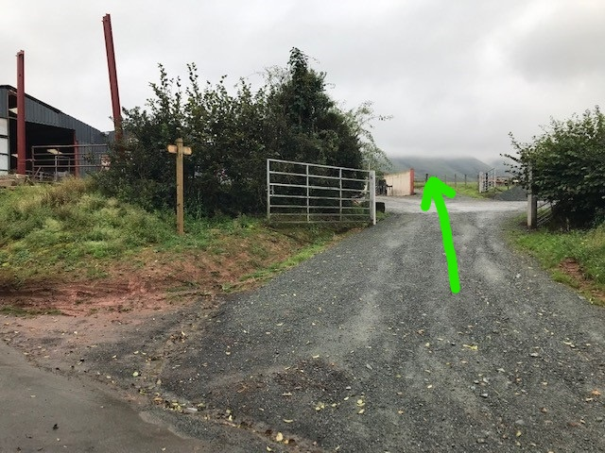

On arrival at the property please follow the footpath straight across from the entrance.
Leaders please do not park in the entrance and use it as a checkpoint.

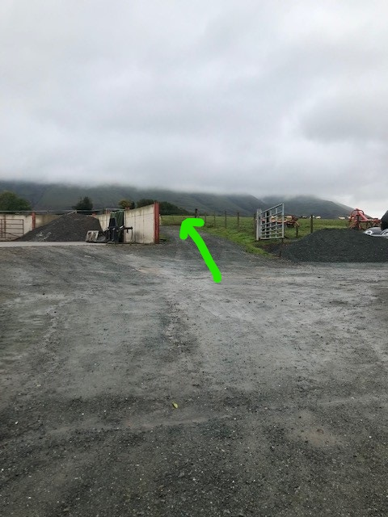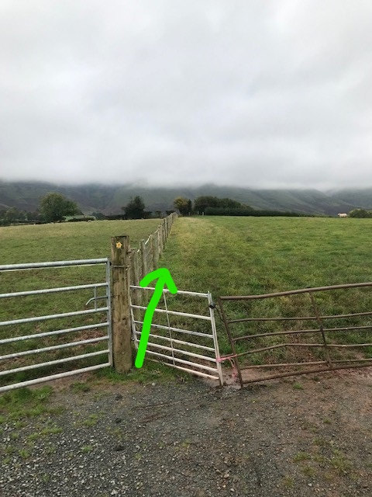

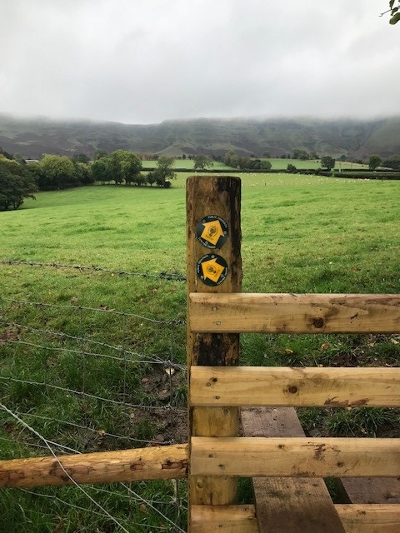

Rights of ways are clearly marked – please use the styles and follow the signs in place, waking along the fence lines as directed!

