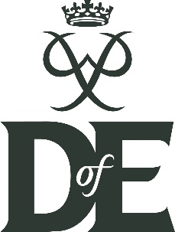
Model release form

Photographer/  camera operator: | The Duke of Edinburgh’s Award (DofE) | Date:
Name of agency  (if applicable): | N/A
Name of model:

I permit The Duke of Edinburgh’s Award (DofE) to exclusively use the image(s)/video/audio clip(s) and quote(s)/stories taken on the above date for all aspects of communications and marketing of the DofE, including, but not limited to, PR, advertising, promotional materials including leaflets and posters, editorial, digital content, stakeholder (including supporters’) promotional DofE content and PowerPoint presentations.
I understand that I do not own the copyright of image(s)/video/audio clip(s) or quote(s) that I supply.
Please tick here to confirm your acceptance of the terms and conditions.
Signature or email address if completing electronically: |  | Date: | / /
Address:
Town: |  | Postcode:
Email address: |  | Contact No:

