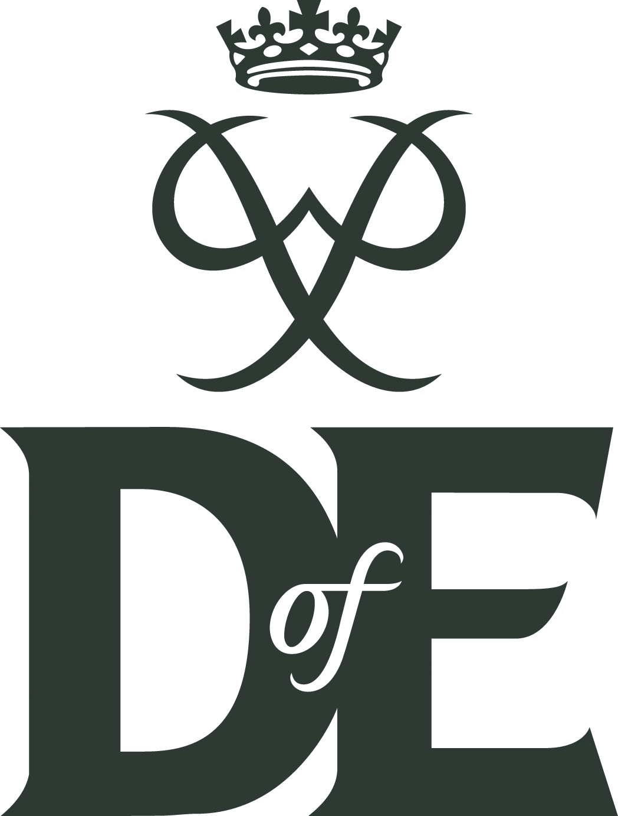
Template email for potential participants
Dear [name],
This term, you’ll have the opportunity to sign up to do your [Bronze/Silver/Gold] Duke of Edinburgh’s Award (DofE).
The DofE is a chance to gain new skills and interests, get fit, have fun and broaden your horizons. And, when you complete your programme, you’ll achieve a highly respected Award that can help open doors in the future, whatever you’re hoping to do.
The DofE’s non-competitive and open to all young people – it's about setting your own personal aims, overcoming your own challenges and pushing your own boundaries.
You’ll do [four/five] sections: Skills, Volunteering, Physical and your Expedition [if Gold, and Residential]. You can choose your activities – either improving something you already do or discovering something completely new.
During and in the aftermath of the COVID-19 pandemic, participants who complete their Skills, Volunteering and Physical sections will receive a special DofE Certificate of Achievement – a formal recognition, by the DofE, of the efforts you’ve made and the skills you’ve gained at this extraordinary time. If you go on to do your expedition [if Gold, and residential] you’ll also achieve your DofE Award.
Find out more here [link to Bronze, Silver or Gold presentations with film], and please get in touch with me if you have any questions or would like more information about doing your DofE.
[Name]
DofE Manager

