Useful information
Introduction
The Isle of Man is a little different to most of the other Expedition Areas, it is like going abroad without the hassle.
- While geographically being part of the British Isles it is not part of the United Kingdom.
- It is an internally self-governing Crown dependency, its parliament being ‘Tynwald’, the oldest continuous parliament in the world.
- It uses its own money although this is linked to sterling, and British notes and coins which are happily accepted everywhere.
While the Isle of Man is small, compared to many other Expedition Areas, there are many opportunities for some great expeditions.
Getting to the Island requires greater planning than a visit to many other areas - however communications are good and the extra effort can make your venture more of an event.
Because the Isle of Man is compact and hosts some large motor racing events, during which some roads are closed, we advise to avoid these very busy times. Also, the cost of travelling to and from the Island increases at these times too.

Maps and information
Isle of Man Expedition Area information
Local maps
The Landranger 1:50000 map Sheet 95 covers the Isle of Man and is widely available. The Isle of Man Department of Infrastructure produce a footpath and public rights of way (1:25000) map. This is very useful for showing field boundaries, footpaths, and areas where you are free to walk away from footpaths, however, it is important to get the 2004+ issue as on earlier maps contours are still shown in feet. The 1:25000 map is available from the Department of Infrastructure and many Isle of Man bookshops or heritage shops. A Harvey 1:30000 map is also available.
Not all of the Isle of Man is designated as wild country; please use the guidelines to assist with planning your expedition and the map below..
DofE on the Isle of Man
The Isle of Man Department of Education, Sport and Culture Youth Service is the largest Operating Authority, and DofE is very active on the Isle of Man, with many local Award groups going out on over 100 expeditions per season. As well as expeditions it is an ideal venue for residentials and expedition or Leader training.

Planning an expedition
Because of the size of the Isle of Man careful planning of an expedition is essential, the shaded area on the map below shows the areas of true wild country (the vast majority of a Gold expedition should take place within these boundaries). There is some flexibility, such as if a group wishes to visit an area of interest or study or go to a more suitable campsite. However, this should be kept to a minimum and be agreed with the Assessor when the route is first submitted.
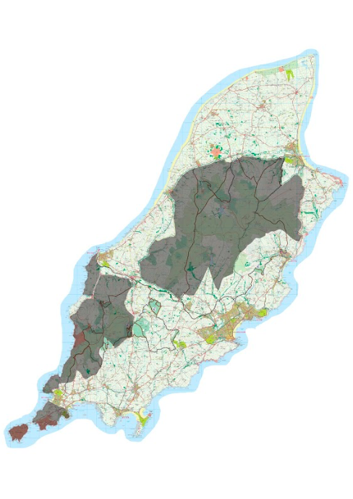
Emergency Planning
The fire service and civil defence operate their own mountain rescue unit.
The main hospital on the Isle of Man is Nobles Hospital, Braddan, Douglas. The Isle of Man Health Service provides emergency treatment free for groups from the UK and EU.
Telephones
Most payphones are card phones and only Manx Telecom cards can be used in these, they are available from many newsagents and tourist information offices.
Mobile phones should not be relied on, as there are areas of the island without coverage. Some mobile phones may not work on the island, so please check your phone works on local networks, international roaming charges may apply.

Weather
The weather in the Isle of Man is, by nature of its location, changeable with low cloud, hill fog and strong winds common. The ‘live’ weather forecasts on Manx Radio (1368 MHz) at 6:00, 7:00, 8:00, 9:00 and 17:00 each day give very good guidance for the next few days.
Ronaldsway Met Office provides an excellent service giving detailed weather forecasts and very useful advice. Recorded Forecasts 0900 6243 300 are updated six times each day. You can talk to a forecaster direct 0900 6243 200, available 24 hours per day.
Familiarisation
Groups should try to spend two full nights on the island prior to the start of the expedition. If you do not wish to camp, there are some inexpensive self-catering properties available for hire, such as:
- Ardwhallan Outdoor Education Centre, West Baldwin (6 miles from Douglas Town Centre). Contact Paul Melling on 01624 853711
- The Venture Centre Bunkhouse, Maughold (2 miles from Ramsey Town Centre). Contact either Mike or Simon Read on 01624 814240
There are also many low-cost boarding houses in Douglas, details can by obtained from the Department of Enterprise (DE) on 01624 686766.
Busy times
T.T. Fortnight: The Isle of Man TT is a series of motorcycle races around a 37-mile road circuit, which is closed to the public for many hours at a time. This is usually a two-week period starting at the end of May. The dates can change slightly, however this is well publicised by the DE. This is also the Island’s busiest period, the cost of travel increases, all accommodation is full and campsites suitable for expedition are impossible to find; wild camping is not allowed. The Festival of Motorcycling (formally the Manx Grand Prix) is similar to the TT but quieter and ventures are possible during this time, it is usually held at the end of August /beginning of September.
Car Rallies: Many roads are closed, and access is almost impossible during these, however, campsites are available and an extra day’s familiarisation can provide some spectacular viewing. Dates and details are available at www.gov.im/tourism
Tynwald Day: 5 July: The Manx National Day, when new laws are announced to the population by the Lord (or her representative) from ‘The Hill’ in St Johns. This is a unique occasion and is well worth a visit - however expeditions should steer clear of St Johns on that day (unless you have it as part of your aim).

Getting here

Getting to the Isle of Man is a little more challenging than many other areas, however, travelling by ferry or plane can help make your expedition a greater experience.
By sea:
From: Liverpool, Heysham, Dublin and Belfast, contact the Isle of Man Steam Packet Company, Imperial Buildings, Douglas, Isle of Man, Tel: 01624 661661 www.steam-packet.com The Steam Packet Company may give special fares to DofE participants if you ask them, however ‘footloose’ or ‘rail and sail’ fares are good value.
By air:
From: Belfast City, Belfast International, Birmingham, Bristol, Dublin, Glasgow, Gloucester, Liverpool, London City, London Gatwick, Manchester.
In the first instance check out www.manxflights.com for airline providers, except Easyjet, but booking direct from the flight provider’s websites is usually cheaper.
Expedition Processes
Assessors
The Assessor Directory can be accessed via your eDofE account.
Route cards
The purpose of route cards is to provide information for the group, the Supervisor and the Assessor. There are many acceptable forms of route cards – ideally you should use a type that you are familiar with.
Risk assessments
You should complete a risk assessment on your route and group.
Supervision
All expeditions must be supervised by an experienced adult who must be present on the island throughout the expedition and who is responsible for the safety of participants. It is the group’s responsibility to ensure they have a supervisor before they book their expedition. Firm arrangements must exist between the group, Assessor and Supervisor.
Expedition aims
The aim of the expedition may vary from a study of an area to the completion of a demanding journey. However, it is always nice to have a reason to look at the area that you are travelling through, rather than just a hard slog. As the Isle of Man is not part of the UK, and has Elizabeth II as Lord, rather than its Queen, a study of our differences can make an interesting aim.

- Its wealth of ancient and historical monuments and sites, as well as a rich natural history, is ideal for expeditions. Useful information can found at www.gov.im/mnh
- There are many ancient monuments and interesting Celtic and Viking remains, Churches or Viking crosses make an interesting study, as do castles, towers and follys
- Some groups have studied the impact of tourism on the island, looking at the development of transport in the Victorian era. Many different types of railway (some now disused) were developed then
- The geology of the island is interesting, mining being the major industry at the turn of the 20th century
- The bird life is varied, with many species common on the Isle of Man and rare in England
- Ancient byways and footpath development has been studied, maybe look at the different types of footpath from bridleways and greenways to public rights of way
- The fate of Manx hill farms has been studied, as has the design of those old ‘crofts’ or ‘tholtans’
- The island’s Parliament and Government can be looked at, 1000 years was celebrated in 1979, the oldest continuous government in the world
- Geocaching and Letterboxing can add a different dimension to an expedition
Lots of information can be found via the Manx Government website - www.gov.im

Routes
As the Isle of Man is compact, careful route planning is essential (supervising can be less stressful though and easier on car mileage). We suggest routes take in both coastal and inland sections of the island. It is important that you plan your own route, but here are a few pointers.
- For expeditions that concentrate on distance we suggest planning a route that starts or finishes in the Southern part of the island taking the footpaths over or around Cronk ny Arrey Laa, and down over the Carnanes to Port Erin and the Sound
- In the centre of the island there are a mixture of routes through or over the central hills (between the A1 from Crosby to St Johns to the A3 from Kirk Michael to Ramsey and the A2 from Ramsey via Laxey). Most of the footpaths are fairly easy to follow in good weather, but in mist and fog you need to keep your wits about you
- Parts of the Raad ny Follyn (Coastal footpath) are worth walking especially sections around the Southern part of the island from Peel to Port St Mary
- If you wish to follow parts of the other long distance footpaths you may - but please only plan to use fairly short distances of these at any one time. Use of the Heritage Trail should be only used to move between areas of wild country or between places of study
- Most of the upland hills are open for ‘public rambling’ these areas are marked on the 1:25 000 map as a darker green shaded area, but generally they are areas above 350 metres, so if you wish to walk ‘off piste’ please feel free. However, in all other areas public rights of way must only be used
- Mountain biking is not permitted on public rights of way, unless indicated on the Mountain Bike Route Map
Camping
The owners of campsites are all very welcoming of DofE groups, but please remember that misbehavior impacts on local DofE groups too.
Wild camping requires permission from DEFA.

