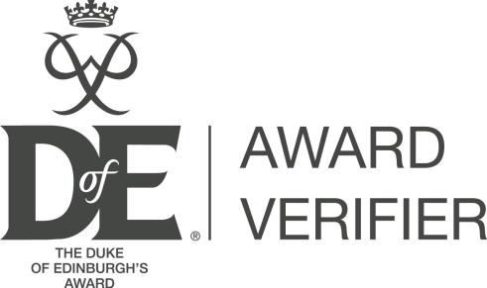
February 2023

Award Verifier: Course overview

The Award Verifier (AV) course equips Award Verifiers with the necessary DofE programme and practical knowledge to confidently meet the purpose of the role, execute key tasks and ultimately deliver high quality Award Verification in eDofE.

For full information, see the course webpage and flyer at: www.DofE.org/av.

Frequently asked questions:

What is the course?
The Award Verifier course is a compulsory component of the learning package for Award Verifiers; there is also an Introduction to the Award Verifier e-learning module which needs to be undertaken before the course. This module will prepare individuals for the role by outlining the key tasks, DofE roles and how Award Verifiers use eDofE ahead of attending the course. The Award Verifier e-learning and the e-induction e-learning module are compulsory course pre-requisites for new Award Verifiers.

The course itself will introduce the purpose of the Award Verifier role, programme requirements and how to check that these have been met in eDofE. It will also outline the importance of evidence and Assessor reports in upholding the quality of all completed programmes.

Is there any required pre-learning?
In order to receive a certificate, Award Verifiers must complete two e-learning modules prior to attending the course:
- e-induction
- Introduction to the Award Verifier e-learning

Are there any entry requirements?
No, it is a basic course, intended for beginners, but you are required to complete the e-induction and Introduction to the Award Verifier e-learning module before attending an Award Verifier course.

Is there any other complementary learning that as a Verifier I could do?
We encourage all of our Award Verifiers to attend an Introduction to the DofE (IttDofE) course. This is not compulsory, but is highly recommended. It will help to broaden your general understanding of the DofE.

Is the course compulsory?
Yes. Award Verifiers are required to complete the two e-learning modules and the course. Award Verifiers will only receive a certificate if all three are completed.

Will I have to pay for the course?
There is no charge for AV courses.

Will I have to do a test or assessment?
There is no formal test, but the trainers will check that all learning outcomes have been covered.

What qualification will it give me?
The AV course is a DofE course and part of our Modular Training Framework. You will receive a DofE certificate. This course is not accredited by any external bodies.

For newly Licenced Organisations, how long do we have to ensure all new Award Verifiers have been trained?
As with new DofE Managers, all new Award Verifiers must have completed the compulsory training within 6 months of the licence being signed.

Who should do the course?

This course is aimed at new Award Verifiers.

Who should undertake the Award Verifier role?

Award Verifiers must be independent from the direct delivery of DofE Programmes (i.e. a Leader cannot also be the Verifier). We advise that all Award Verifiers possess the confidence and are in a position of authority to uphold the quality of all completed Awards. Award Verifiers must be comfortable raising programme quality issues with the DofE Regional / Country office where appropriate. For example, an Award Verifier in a school might be a head of department, or a volunteer within the Scouts.

Does the Award Verifier represent the DofE or the LO?
Award Verifiers will be nominated by their Licensed Organisation, but the DofE Charity is responsible for their direct appointment. Regional / Country offices will ensure Verifiers have all necessary permissions in eDofE, but Verifiers are empowered by their Regional / Country office to uphold programme quality within their LO. They are responsible for liaising with the DofE Manager to address general programme quality concerns, but will also raise more serious quality issues with the DofE Office. E.g. you might identify that an Expedition Assessor has written an identical Assessor’s Report for more than 30 participants.

Where do I go to find out more – or to book onto a course?
Visit the AV webpage: www.DofE.org/av. Further information is available and the ‘Opportunities Finder’ can be used to find a course to book onto.

